Update Areawise Price And Status

Overview : This section explains how to update the price and availability status of menu items for specific service or delivery areas (such as AC, Parcel, Online, etc.) in the Petpooja Dashboard.
There are two methods available:
- Area-wise Bulk Update (Bulk Sheet Upload)
- Area-wise Item Price Update (Single Item Update)

1.Area-wise Bulk Update (Bulk Sheet Upload)

Overview : The Area-wise Bulk Sheet Upload feature allows restaurants to update multiple menu items in a single process using an Excel sheet. With this feature, users can efficiently modify item prices, item availability (ON/OFF), packaging charges, dietary tags (Veg/Non-Veg), and area-wise pricing for multiple items at once, eliminating the need to update each item individually. This feature is ideal for bulk menu updates, seasonal price revisions, and maintaining different prices for different dining areas or service types. After updating the exported sheet, users can upload it back to the Dashboard to apply the changes.
Menu Management → Base Menu → Quick Actions → Area-wise Bulk Sheet
URL: https://menu.petpooja.com/admins/item_areawise_prices
This feature is useful for restaurants that maintain different prices for different service areas such as:
- AC
- Parcel
- Online
- Home Delivery
- Garden
Using this option, you can:
- Download the existing Area-wise Bulk Sheet.
- Update the required fields.
- Upload the edited sheet.
- Apply all changes in one go.

Step 1: Log in to the Dashboard
Open the Petpooja Dashboard using the following URL: https://billing.petpooja.com
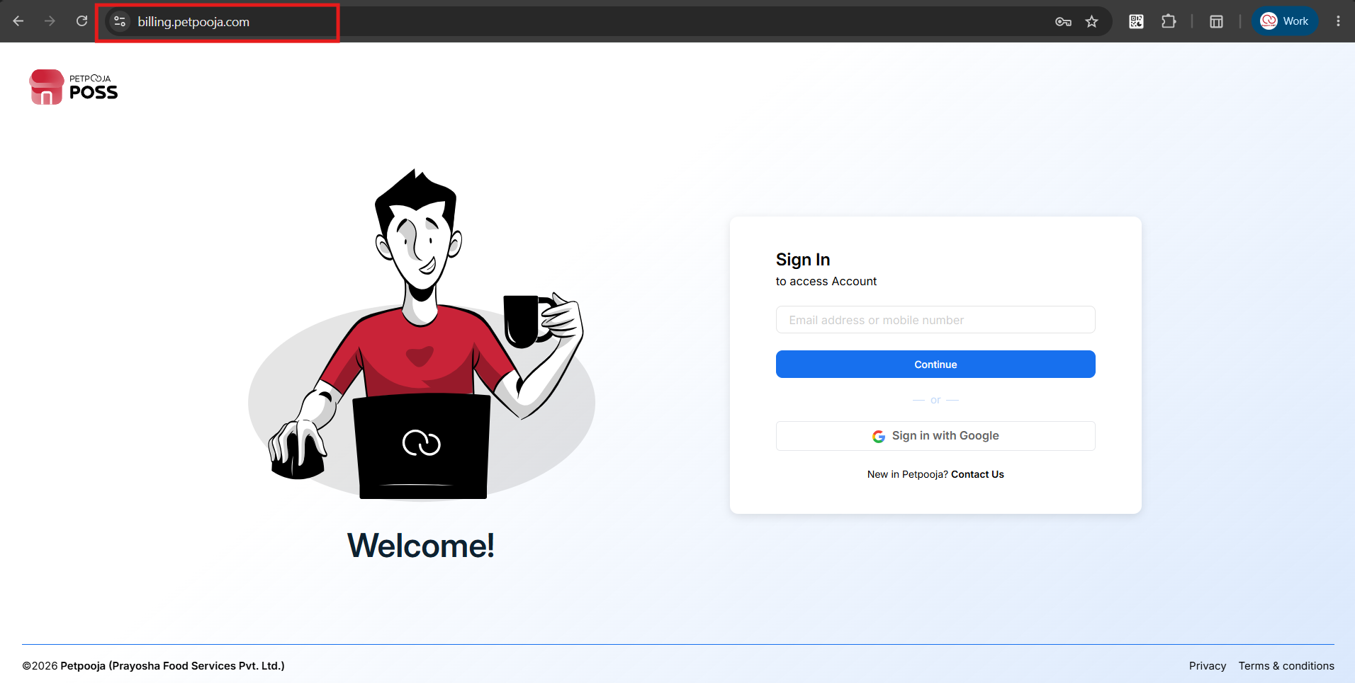
{ Image Name: Petpooja billing dashboard Login ,
Description:The highlighted section indicates the URL of the Petpooja Billing Dashboard login.This is Step 1 to Find Area-wise bulk sheet }

Step 2: Navigate to Menu Management >> Menu & Discount
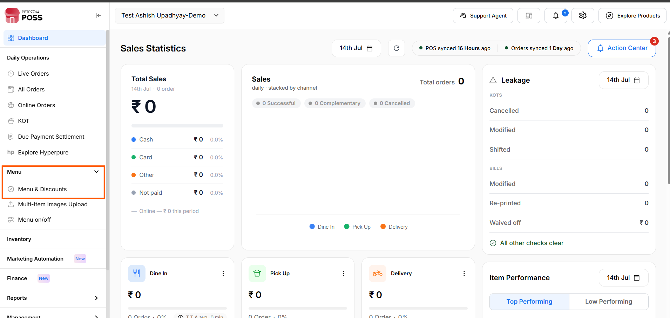
{Image Name: Menu & Discount page,
Description: The highlighted section indicates the Menu & Discount section. This is Step 2 to Find Area-wise bulk sheet }

Step 3: Click on “Manage Menu” under the All in One Menu

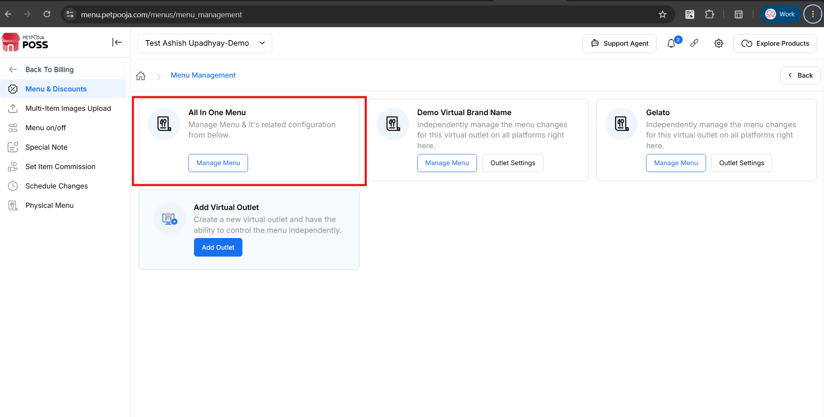
{ Image Name: All in one Menu.,
Description: The highlighted section indicates the All in One Menu . This is Step 3 to Find Area-wise bulk sheet }

Step 4: Click on “Base Menu”
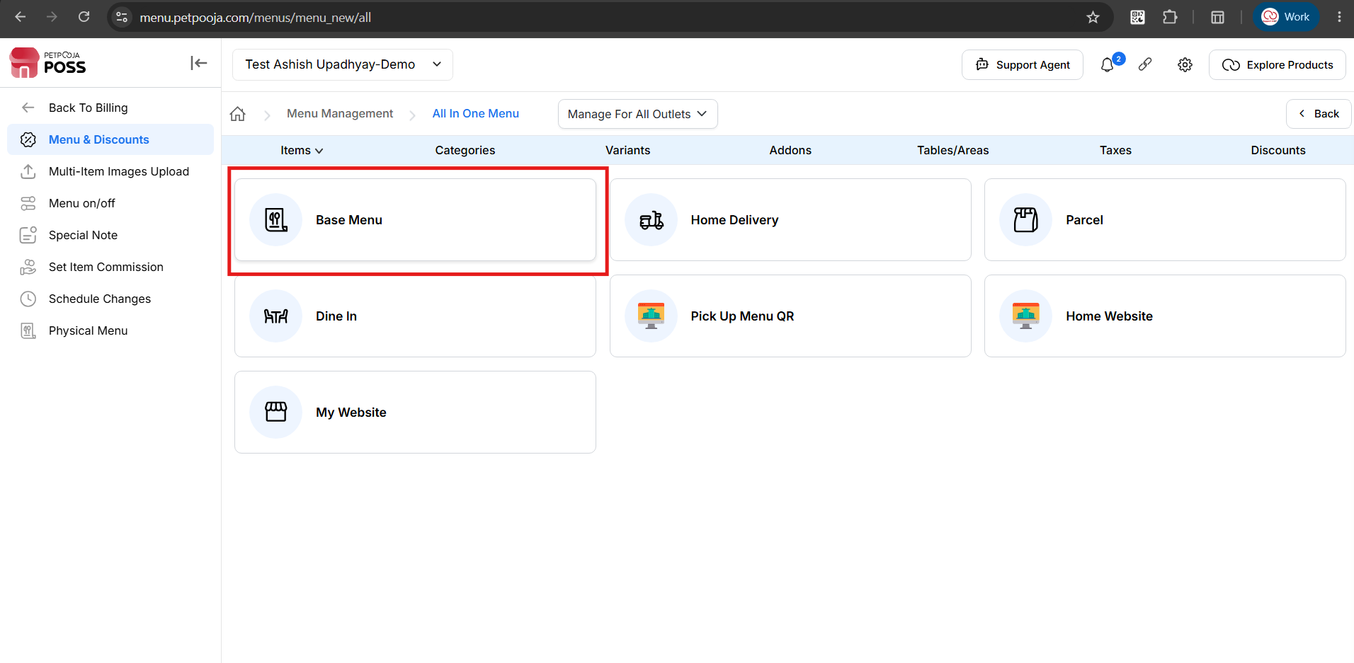
{ Image Name:Base Menu,
Description: The highlighted section indicates the Base Menu . This is Step 4 to Find Area-wise bulk sheet }

Step 5: Click on Quick Action and in the sub menu Area-wise Bulk Sheet option highlighted.
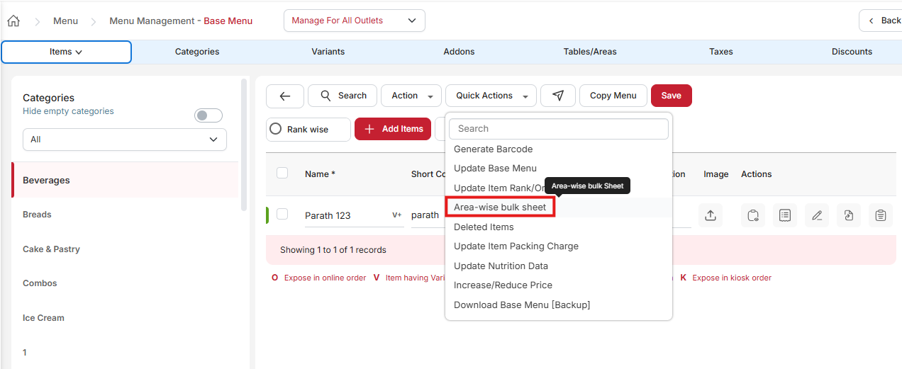
{ Image Name: Quick Action,
Description: The highlighted section indicates the Quick Action . This is Step 5 to Find Area-wise bulk sheet }

Step 6:Click the on button "Export Area-wise Bulk Sheet" link to download the existing Area-wise pricing sheet.
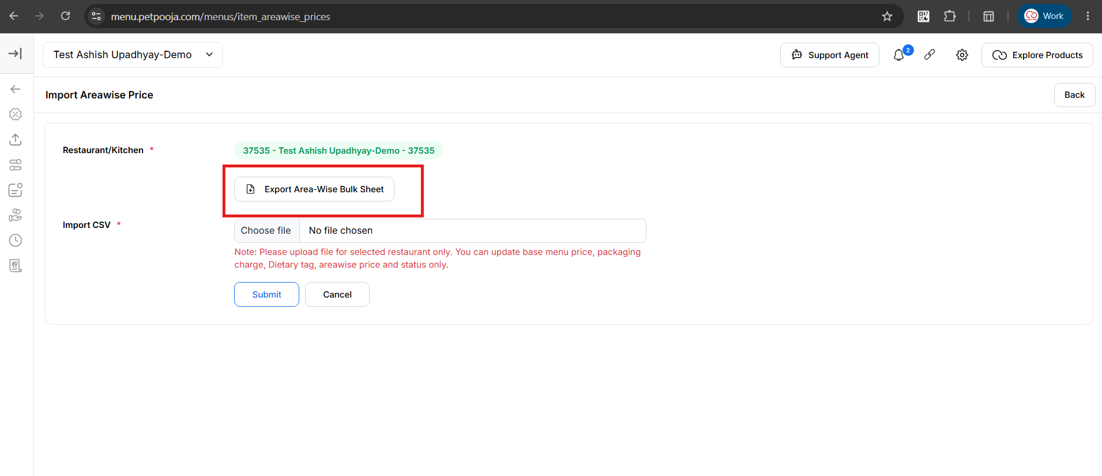

{ Image Name: Export Area-wise Bulk Sheet page,
Description: The highlighted section indicates the Export Area-wise Bulk Sheet . This is Step 6 to Find Area-wise bulk sheet }

Step 7: Select Group, Category and Areas & click on “Export button”
This screen allows users to export menu data based on selected Groups, Categories, and Areas.After exporting the sheet, required changes can be made before uploading it again on the same page.
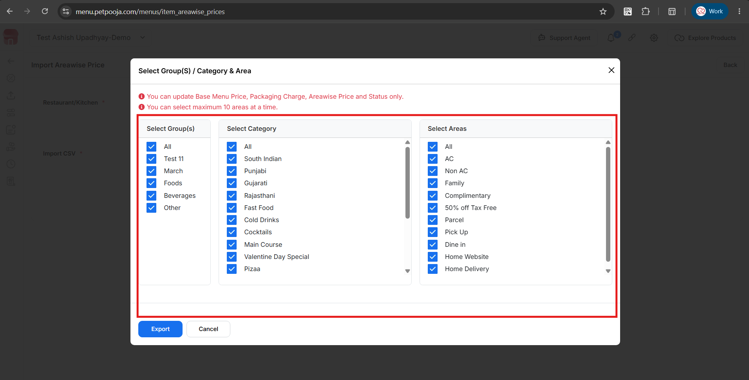

{ Image Name: Select Group(s) / Category & Area,
Description: The highlighted section indicates the Group, Category & Areas. This is Step 7 to Find Area-wise bulk sheet }

Step 8:After updating the prices in the exported sheet, upload the same file from the page where it was originally exported & click on the Submit button.
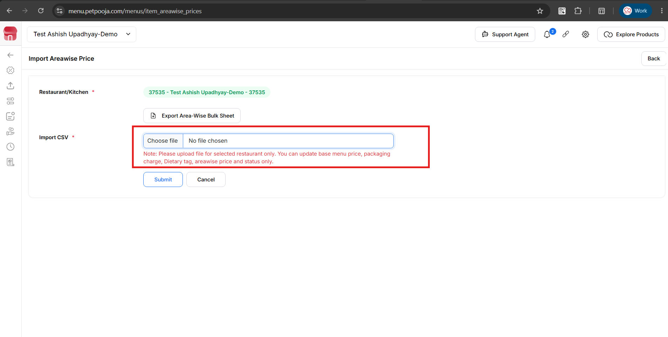
{ Image Name: Import Areawise Price,
Description: The highlighted section indicates the Choose file option. This is Step 8 to Find Area-wise bulk sheet & upload the same }

Step 9: Perform Manual Sync in POS and Trigger Menu for online platforms.
- After the price sheet is uploaded successfully, perform a Manual Sync in the POS system to apply the updated prices.
- If the updated prices are also applicable to online ordering platforms (such as Swiggy, Zomato, etc.), trigger the Menu Sync to update the prices on all connected online platforms.

2: Area-wise Item Price Update (Single Item Update)
Overview:The Area-wise Item Price Update (Single Item Update) feature allows users to modify the price of a specific menu item for a particular area without affecting its price in other areas. This is useful when only one item's price needs to be updated for a selected dining area, outlet section, or service type, eliminating the need for bulk price updates.Using this option, users can quickly maintain area-specific pricing while ensuring accurate billing across the POS and online ordering platforms. After updating the price, perform a Manual Sync in the POS. If the item is available on online platforms, trigger the Menu Sync to reflect the updated price on all connected channels.
This feature is available under:
Menu Management → Base Menu → Quick Actions → Area-wise Bulk Sheet
URL: https://menu.petpooja.com/admins/item_areawise_prices
This feature is useful for restaurants that maintain different prices for different service areas such as:
- AC
- Parcel
- Online
- Home Delivery
Using this option, you can:
- Assign different prices to the same item for different service areas.
- Update prices for individual items without using a bulk upload sheet.
- Maintain accurate pricing across dine-in, takeaway, and online ordering channels.

Step 1: Log in to the Dashboard
Open the Petpooja Dashboard using the following URL: https://billing.petpooja.com

{ Image Name: Petpooja billing dashboard Login ,
Description:The highlighted section indicates the URL of the Petpooja Billing Dashboard login.This is Step 1 to Find Area-wise Item price update }

Step 2: Navigate to Menu Management >> Menu & Discount

{Image Name: Menu & Discount page,
Description: The highlighted section indicates the Menu & Discount section. This is Step 2 to Find Area-wise Item price update }

Step 3: Click on “Manage Menu” under the All in One Menu


{ Image Name: All in one Menu.,
Description: The highlighted section indicates the All in One Menu . This is Step 3 to Find Area-wise Item price update }

Step 4: Click on “Base Menu”

{ Image Name:Base Menu,
Description: The highlighted section indicates the Base Menu . This is Step 4 to Find Area-wise Item price update }

Step 5: Click on Update areawise price & status
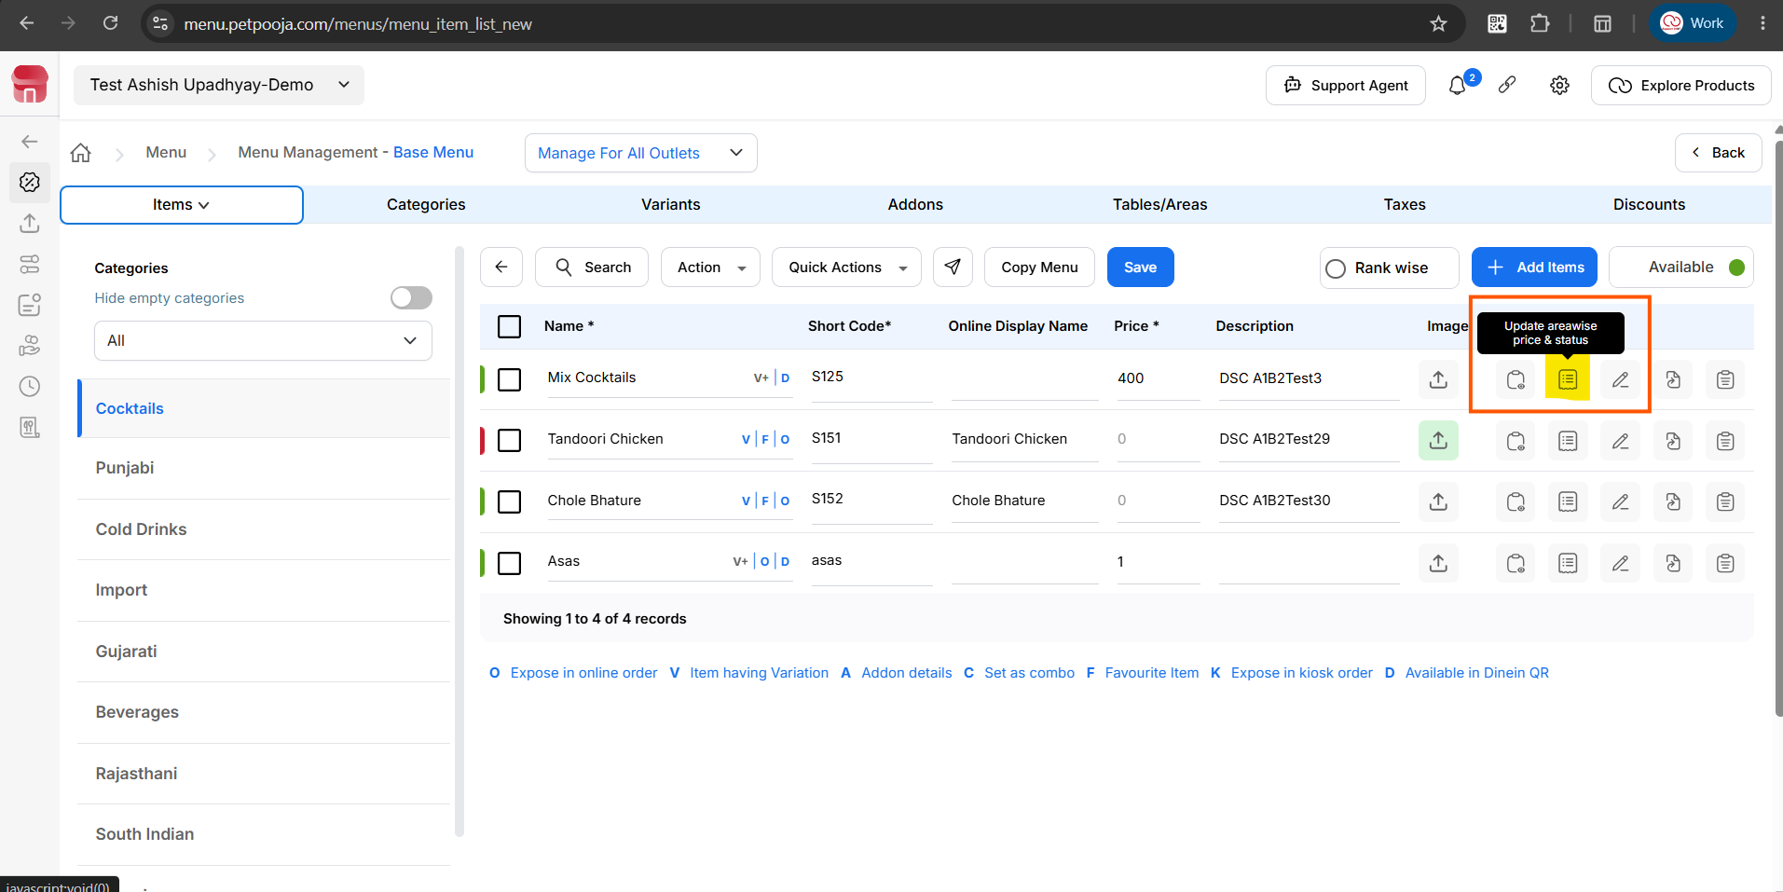
{ Image Name:Item Actions ,
Description: The highlighted Page icon next to the Edit button opens the Update Area-wise Price & Status window. Click this icon to view and update the item's area-wise price and availability status for different areas.}

Step 6: Click on Update areawise price & status
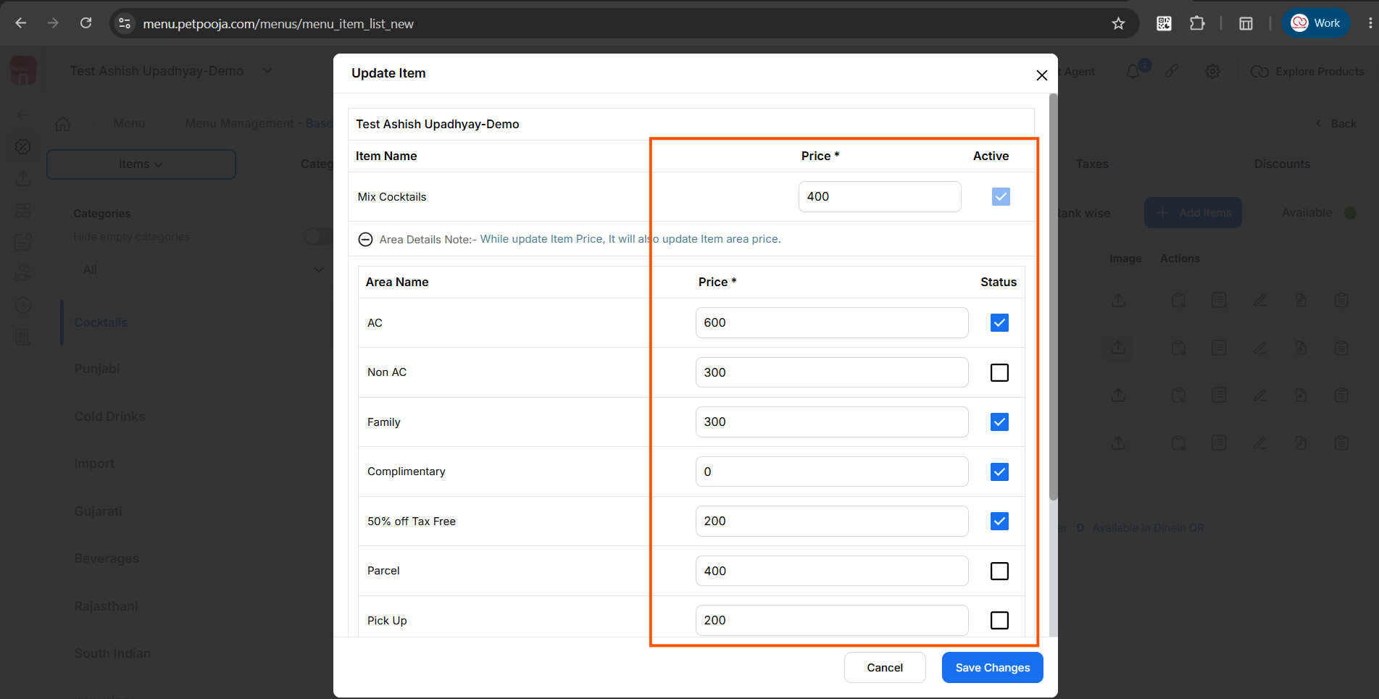
{ Image Name: Update Item,
Description: The highlighted section indicates the Update areawise price & status. This is Step 6 to Find Area-wise Item price update }
Step 7 : Click on Update areawise price & status

{ Image Name : Image Name: Enable/Disable Item Availability for a Specific Area
Description : The Status checkbox allows you to enable or disable the selected item for a specific area. Keep the checkbox checked to make the item available in that area, or uncheck it to mark the item as Not Available. After making the required changes, click Save Changes to apply them.}
Important note : If you want to make an item available for online orders, simply check the box next to the item to activate it and expose it to online platforms. After saving the changes, go to the respective online outlet's menu and perform a Menu Trigger for the changes to reflect online.
Example: Zomato and Swiggy.
After that, you can remove an item or mark it as Not Available for any selected area. Simply uncheck the box next to the item and click Save. This allows you to make a single item unavailable in a specific area.
Important note : If you mark an item as Not Available in the Dine-In area, perform a Manual Sync. If you mark it as Not Available for Online areas, you must perform a Menu Trigger for the changes to reflect online.

Step 8: Perform Manual Sync in POS and Trigger Menu for online platforms.
- After the price sheet is uploaded successfully, perform a Manual Sync in the POS system to apply the updated prices.
- If the updated prices are also applicable to online ordering platforms (such as Swiggy, Zomato, etc.), trigger the Menu Sync to update the prices on all connected online platforms.

